M-Files Import Configuration Quick Start Guide
To configure the import select the “M-Files import option” from the dropdown list and select “Start Input” to open the configuration panel.

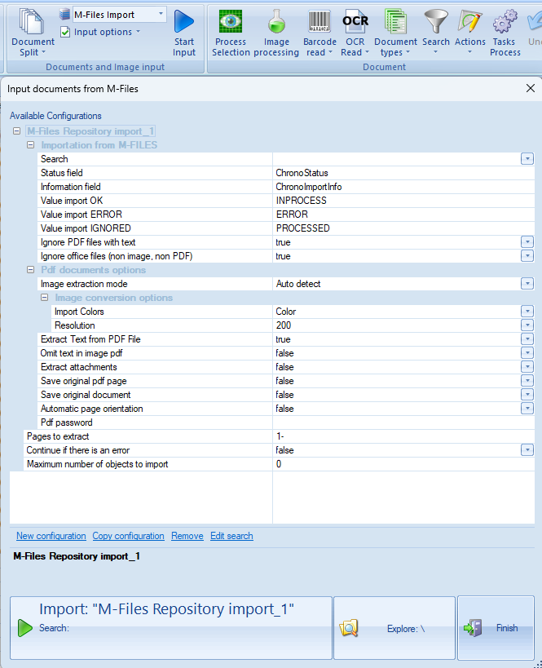
Use the “Search” dropdown to select “Open M-Files searches” to create a new search, select “New”,
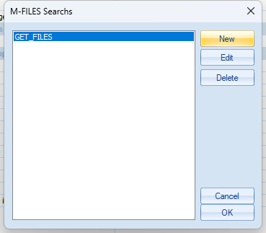
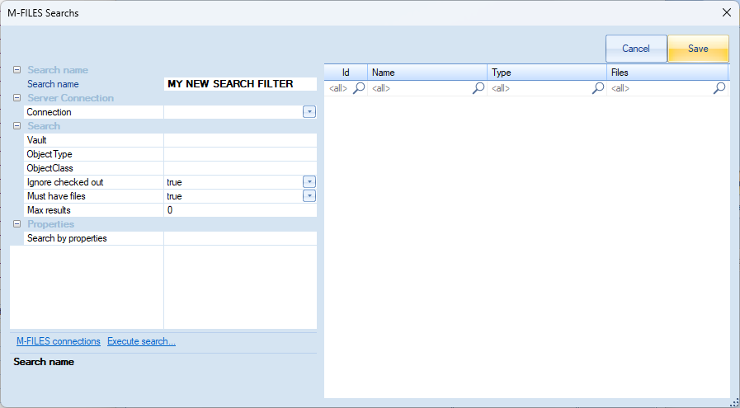
- Enter a name for the new search.
- If you already have an M-Files connection saved then select an existing connection from the dropdown menu, otherwise select “Open connections to M-Files” and select "New”
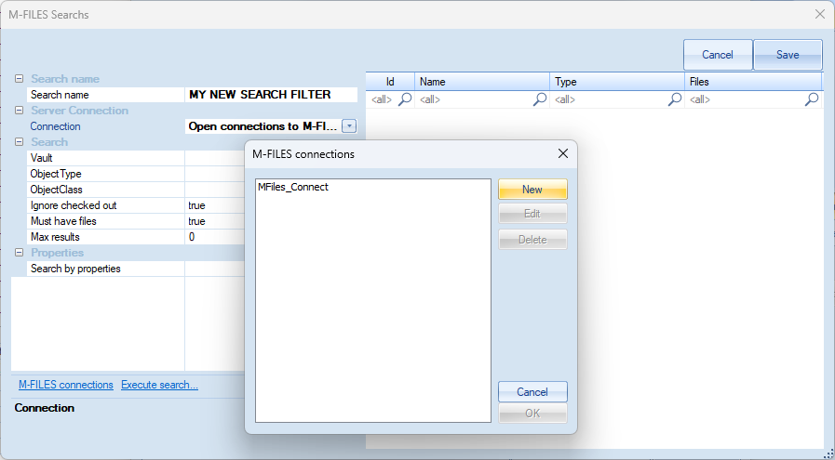

- Configure the details for your vault and use the “Test connection” button to verify the new connection and click “OK” to finish.
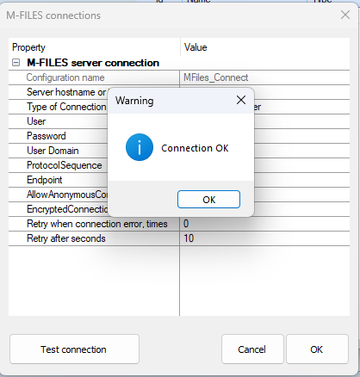

- Now go ahead and select the vault, Object Type and Object Class to use.
You have options to Ignore checked out files, enforce the “Must have files” for the object and also you can limit the maximum number of results returned.
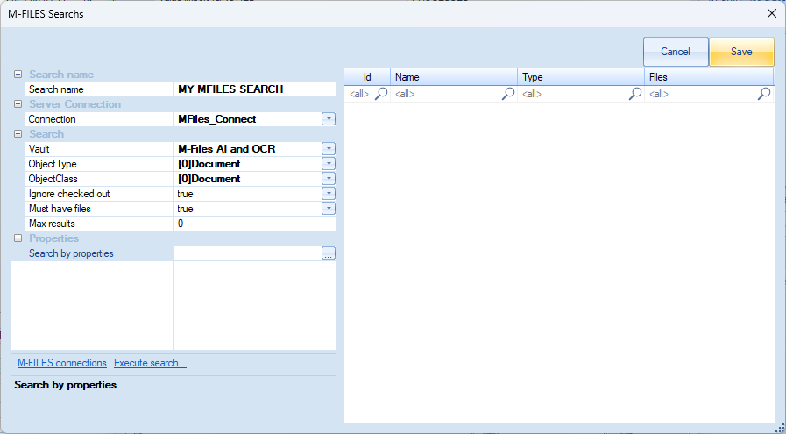
Next we need to configure a search. For this example I have added a status field in my vault using a list.
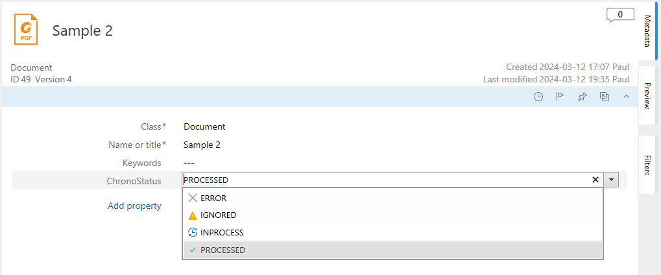
We are going to search for an empty/null status in this field.

Click on the button with “…” to start the search configuration, we can now add our condition.
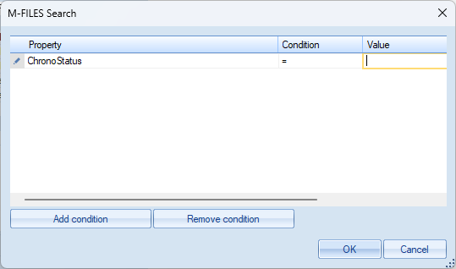
Now click OK to save.
Check the execution of your search using the “Execute Search” option.
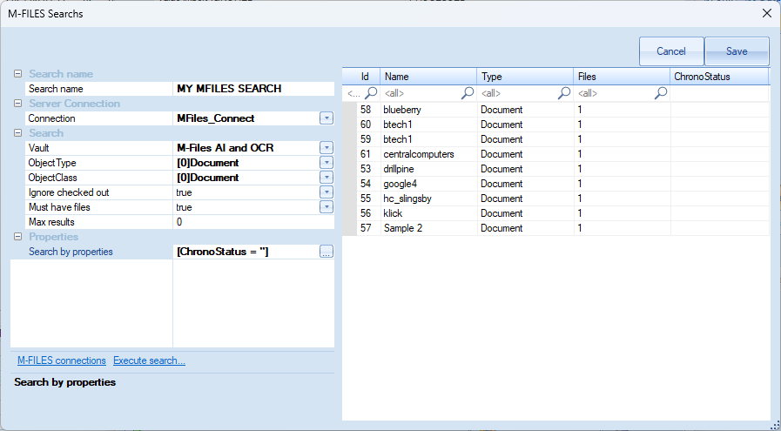
Select “Save” when finished.

- Now that our search is complete, we can continue to finalise our configuration.
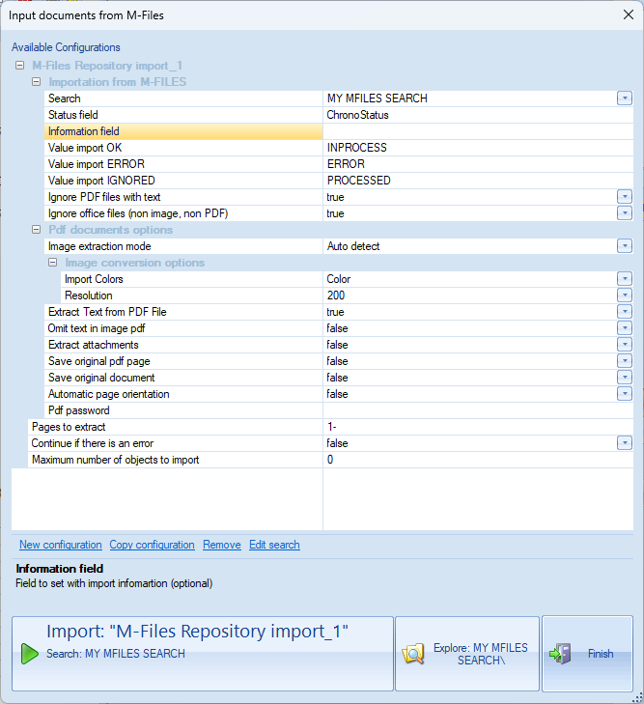

Below is a description for each option.
Importation from M-Files
Search - Used to select search configuration
Status field - The field in M-Files where ChronoScan will return the document processing status
Information field - Optional field to pass information from ChronoScan to M-Files
Value Import OK, ERROR and IGNORED - Used to define the current process status
Ignore PDF files with text - Used to ignore native pdf with text and/or previously ocr’d pdfs
Ignore office files (non image, non PDF) - Used to ignore any files that are not an image or pdf
Pdf document options
Image extraction mode - Used to determine how ChronoScan processes the PDF (render or extract), leave on auto if unsure

Image conversion options
Import Colours - Colour space to use for import
Resolution - Resolution to use for import
Extract text from PDF File - Extract text from text layer if available
Omit text in pdf image - Used to drop the text layer from previously OCR’d files
Extract attachments - Extract any attachments to PDF
Save original pdf page - Used in conjunction with save original pages on export
Save original document - Used in conjunction with save original document on export
Automatic page orientation - Used to orient the page correctly
Pdf password - Used when PDF’s are password protected
Page to extract - Used to specify pages to extract
Continue if there is an error - Used to stop the import if an error occurs
Maximum number of objects to import - Used to limit the number of objects returned

With our options set we can now run the import using the sample files in our vault where the ChronoStatus is null.
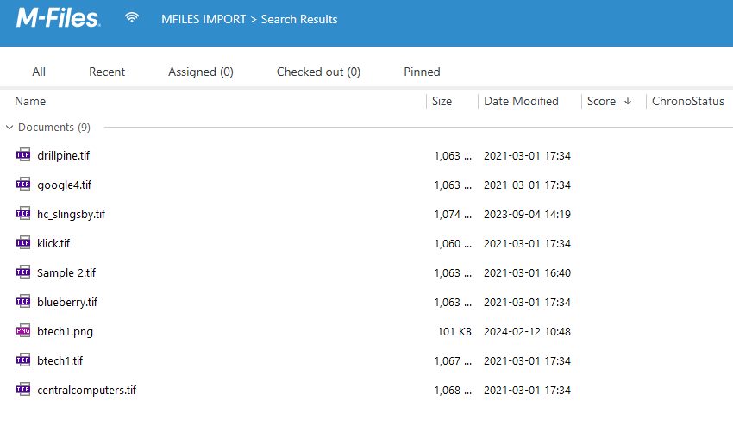
ChronoScan will now create a batch and import the documents.
The status will be updated in M-Files to “INPROCESS”
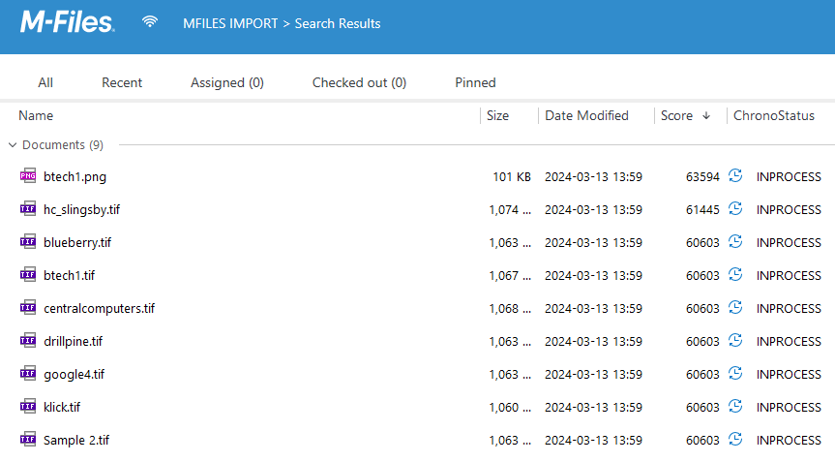

Now you can go ahead and process your batch to OCR, extract data, utilise AI etc.
Also we need to add an export which is beyond the scope of this document so I am only going to mention a couple of items to note as follows,
In the variables wizard you will now find some new M-Files variables to utilise, these contain the text “sysmfiles”
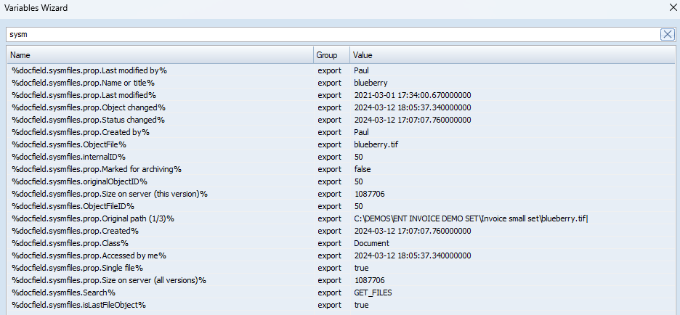

Here I have configured the export to search using the original object ID and replace the tif file with a PDF file, I will update the Name metadata and set the ChronoStatus field as “PROCESSED”
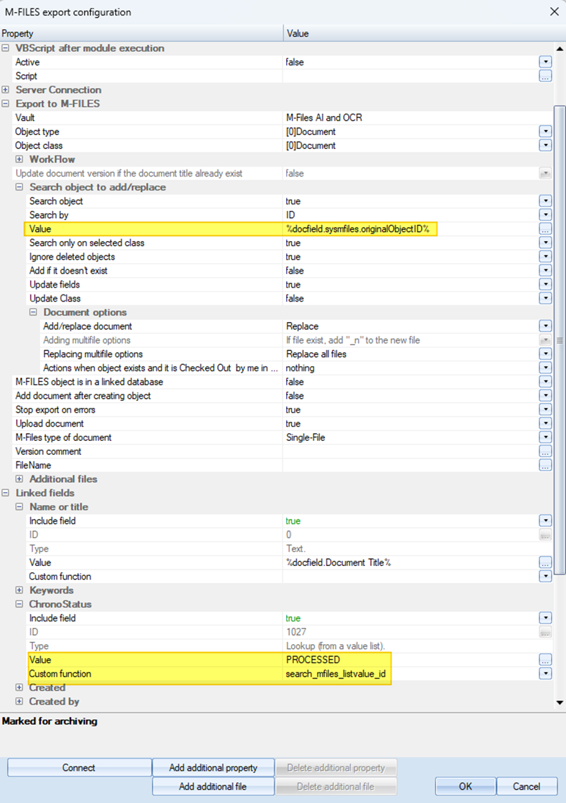

And this will be the final result
